Students’ performance analysis system using cumulative predictor algorithm

In this paper author has introduced new algorithm called cumulative predictor to predict student performance beforehand so they can know whether they are fit for IT dream job or not. Author has built cumulative predictor algorithm on top of decision tree (J48) algorithm and in this algorithm author has put cumulative predictor model generation in loop so the algorithm can choose best accuracy model with less error rate. In paper code you can see decision tree is in loop to get best model

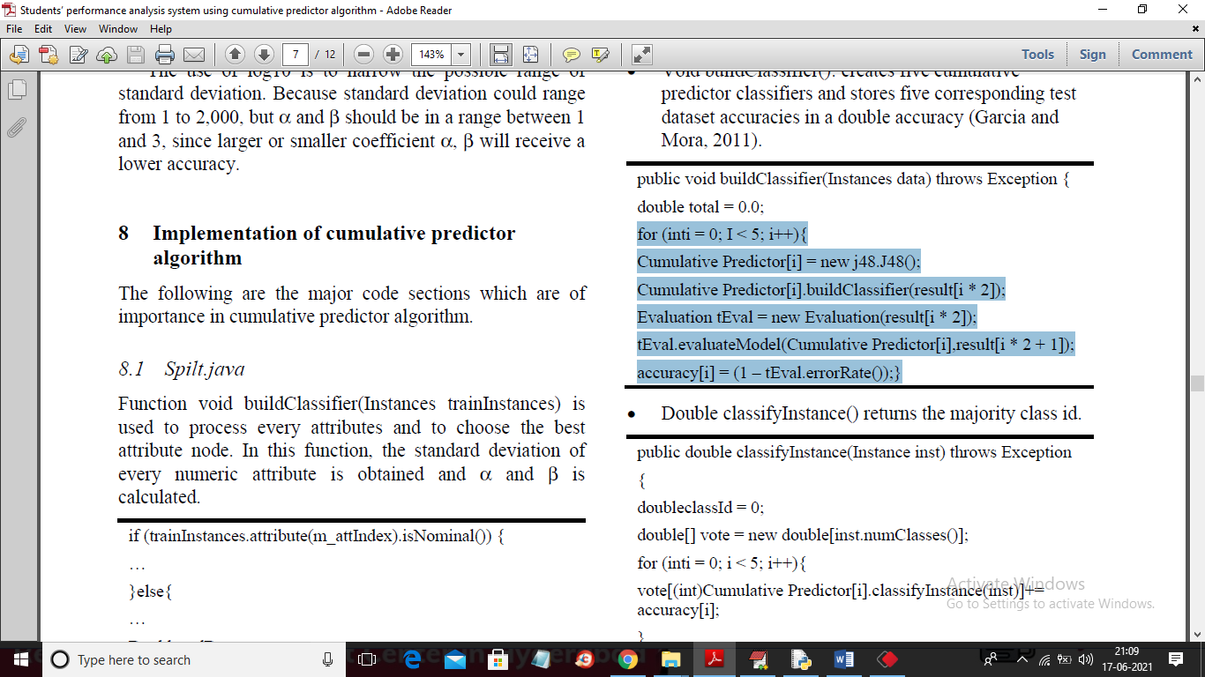

In above screen in selected algorithm you can see cumulative predictor is getting built with decision tree in for loop and selecting model with best accuracy. In our python code also we used same code

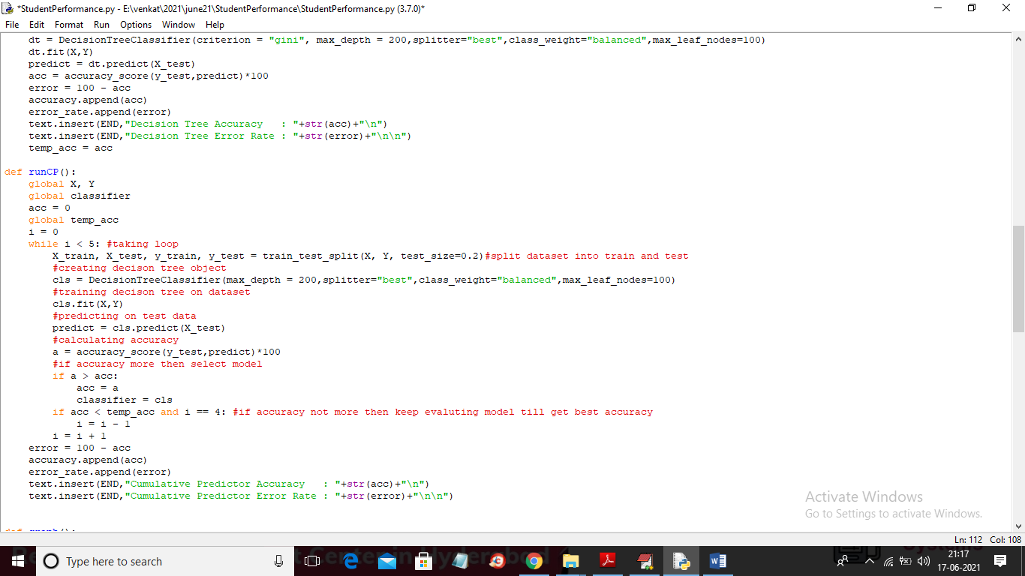

In above python we did same steps to build cumulative predicting model and there may be some change of syntax due to different technology as in paper author used JAVA and we are using PYTHON. We have used same dataset given by you to implement algorithms given in paper and in paper author has compare cumulative predictor with decision tree and Naïve Bayes.

To implement this project we have designed following modules

1. Upload dataset: using this module we will upload dataset to application
2. Preprocess Dataset: dataset contains missing and non-numeric values so by applying preprocessing steps we are replacing missing values with 0 and converting non-numeric values into numeric code. For example NO will be replaced with 0 and YES will be replaced with 1.
3. Run Naive Bayes Algorithm: using this module we will train Naïve Bayes with above dataset and then calculate accuracy and error rate
4. Run Decision Tree Algorithm: using this module we will train Decision Tree with above dataset and then calculate accuracy and error rate
5. Run Cumulative Predictor Algorithm: using this module we will train Cumulative Predictor with above dataset and then calculate accuracy and error rate till we get best accuracy
6. Comparison Graph: using this module we will display comparison graph between all algorithm
7. Predict Performance from Test Data: Using this module we will upload test data and then cumulative predictor will predict performance

Below is the test data used to predict performance

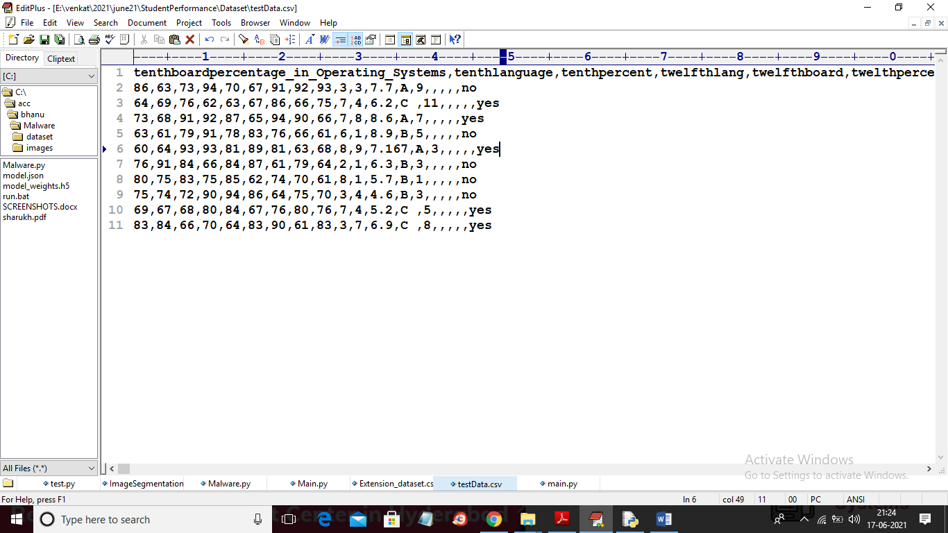

In above test data we don’t have student performance as ‘excellent, poor or medium’ and when we apply above test data on cumulative predictor then it will predict performance.

SCREEN SHOTS

To run project double click on ‘run.bat’ file to get below screen

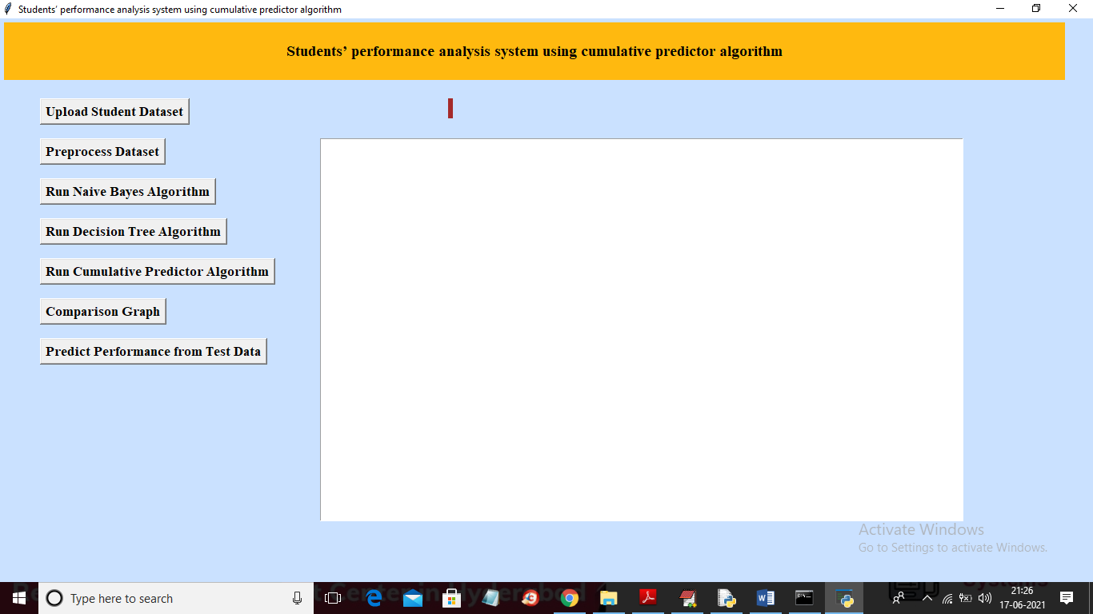

In above screen click on ‘Upload Student Dataset’ button to upload dataset

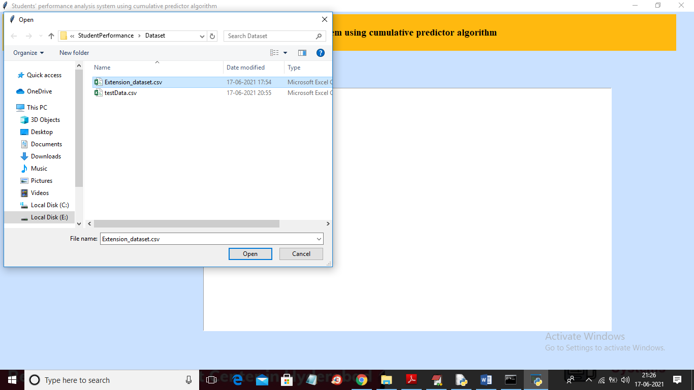

In above screen selecting and uploading ‘Extension_dataset.csv’ file and then click on ‘Open’ button to load dataset and to get below screen

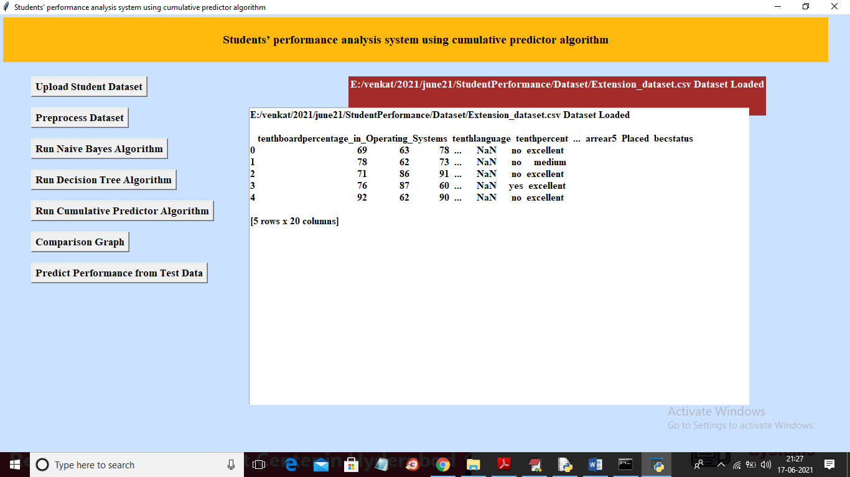

In above screen dataset loaded and we can see dataset contains some missing values ‘NAN’ and non-numeric values and machine learning algorithms won’t accept non-numeric values so we need to preprocess dataset by clicking on ‘Preprocess Dataset’ button

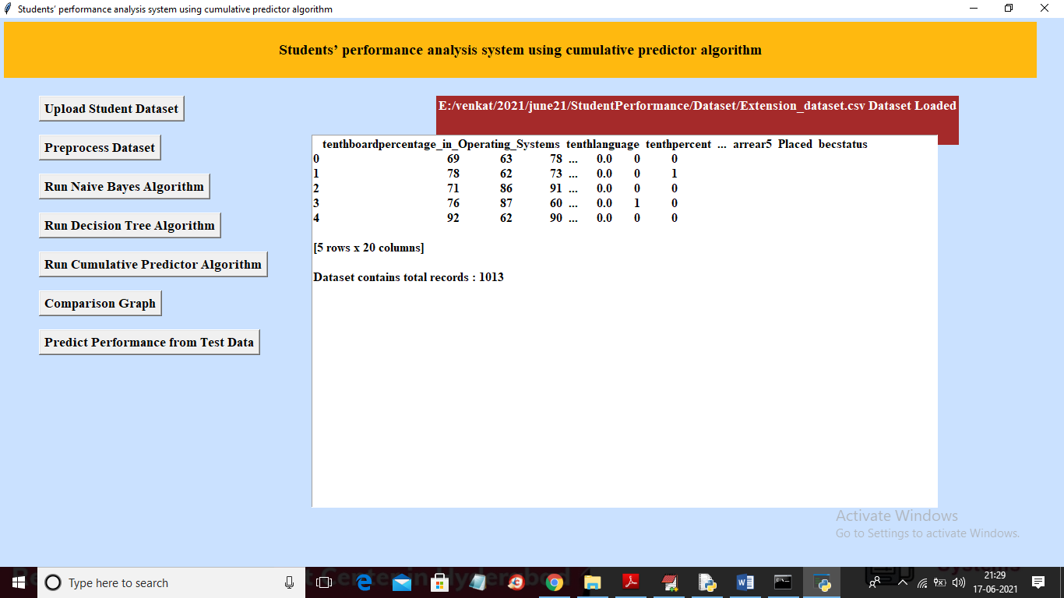

In above screen we can see dataset converted to numeric format and we can see dataset contains total 1013 records and now dataset is ready and now click on ‘Run Naïve Bayes Algorithm’ button to train Naïve Bayes with above dataset

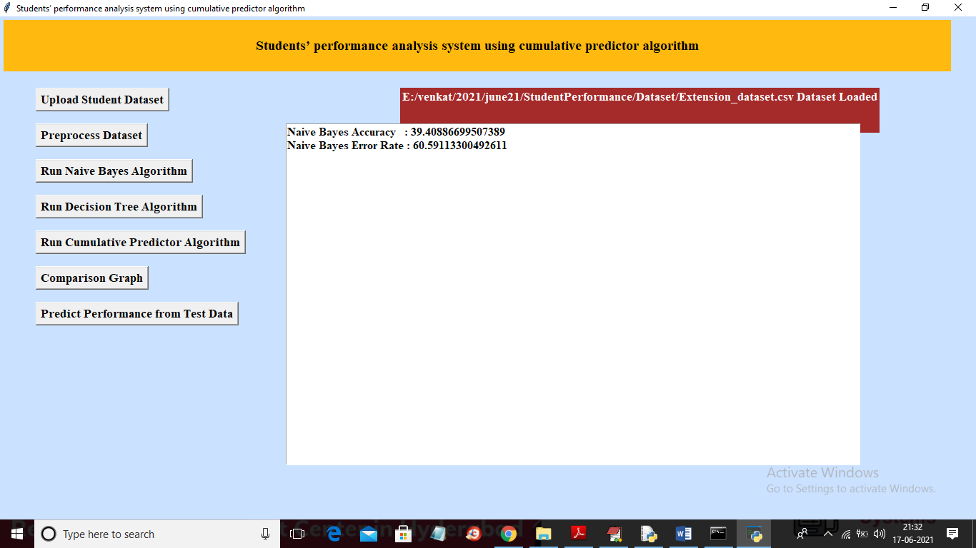

In above screen with Naïve Bayes we got 39% accuracy and now click on ‘Run Decision Tree Algorithm’ button to train above dataset with decision tree

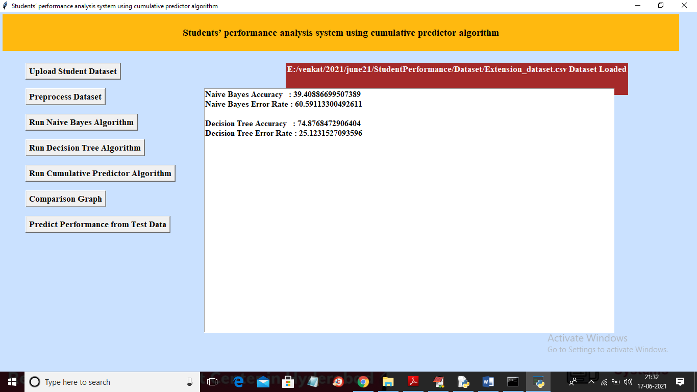

In above screen with decision tree we got 74% accuracy and now click on ‘Run Cumulative Predictor Algorithm’ button to train CP with above dataset

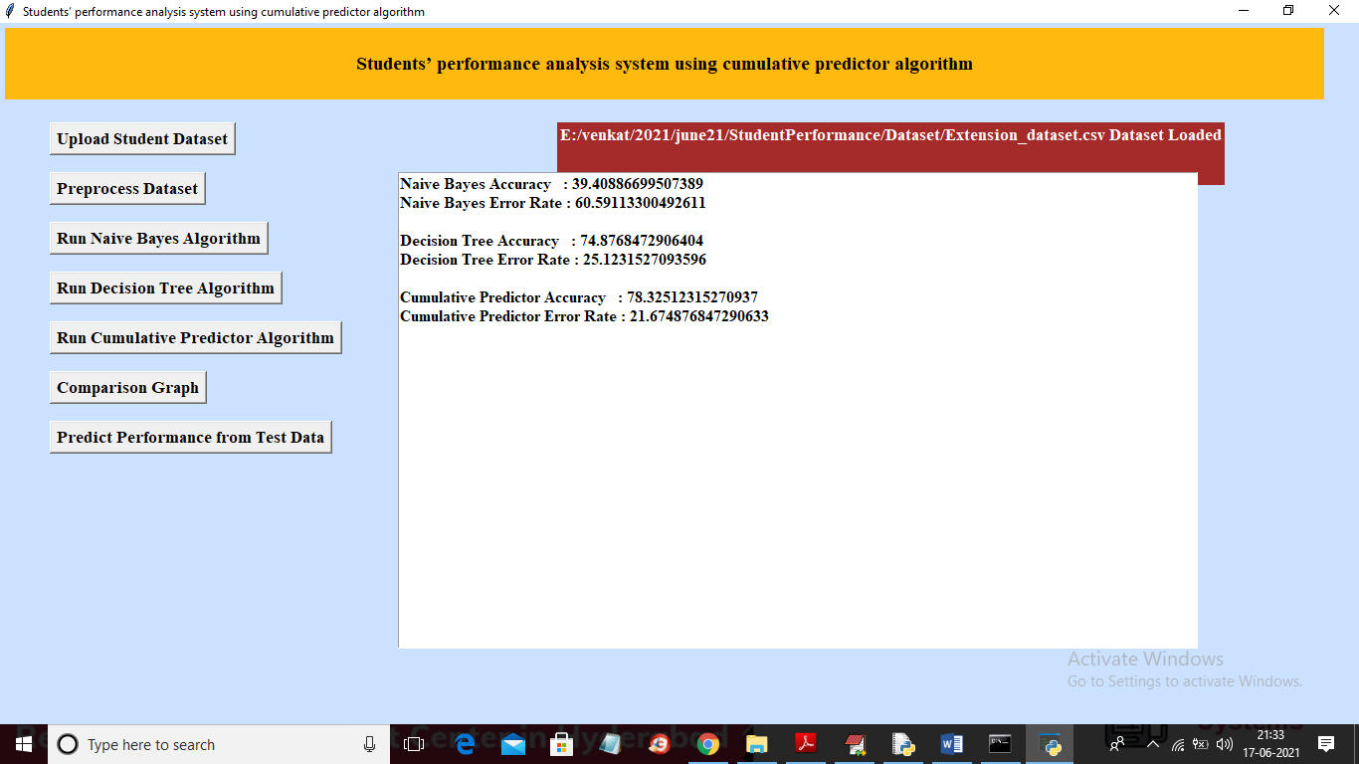

In above with CP we got 78% accuracy and now click on ‘Comparison Graph’ button to get below graph

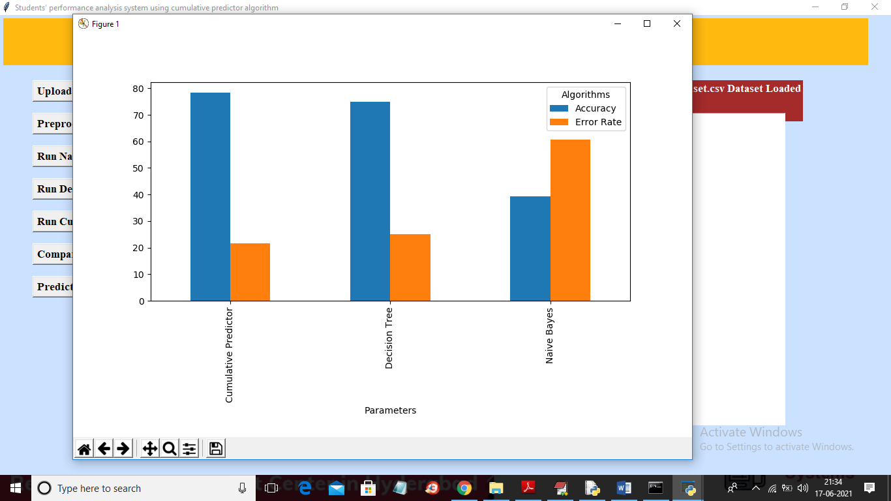

In above graph x-axis represents algorithm name and y-axis represents accuracy and error rate and in above algorithm we can see CP got high accuracy with less error rate. Now click on ‘Predict Performance from Test Data’ button to upload test dataset and to get prediction result

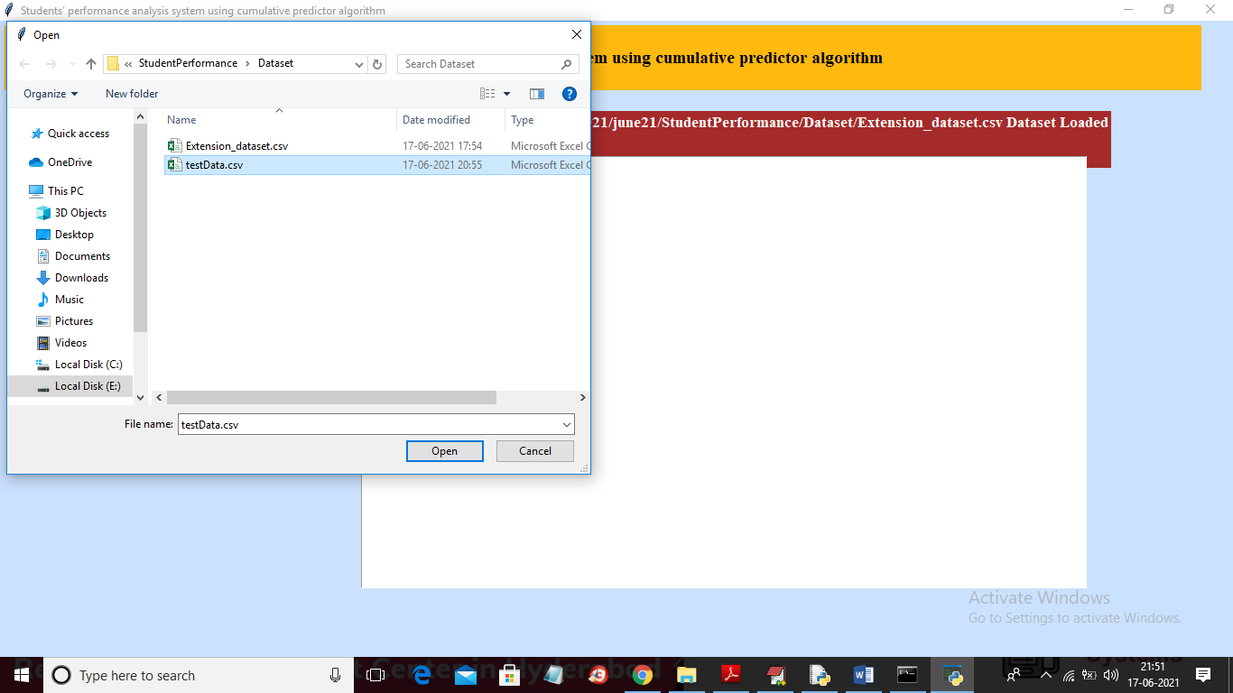

In above screen selecting and uploading ‘testData.csv’ file and then click on ‘Open’ button to get below prediction result

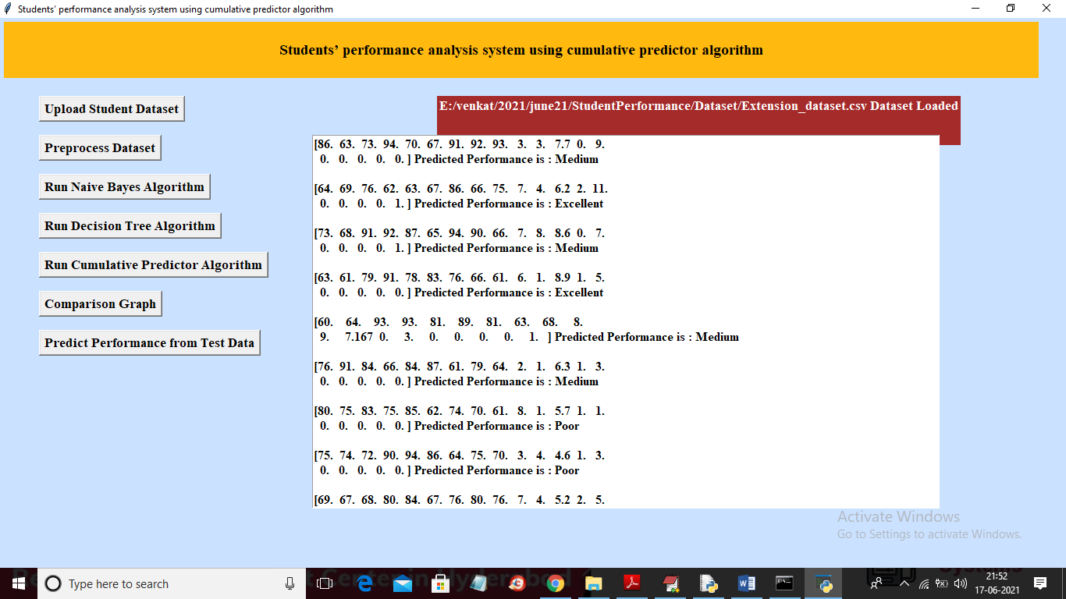

In above screen inside square bracket we can see student performance data and after square bracket we can see the prediction result from CP algorithm.